**Guidelines on the Sediment Connectivity stand-alone application *SedInConnect***

**Release: 2.0**

(and 2.1)

**Marco Cavalli, Stefano Crema, Lorenzo Marchi**

**CNR-IRPI Padova (PP4)**

November 2014

Index

[1 Introduction 3](#_Toc398633083)

[2 Background theory 4](#_Toc398633084)

[2.1 Index of sediment connectivity 5](#_Toc398633085)

[2.2 Refinement of the index of sediment connectivity implemented in the tools 6](#_Toc398633086)

[2.2.1 Slope 6](#_Toc398633087)

[2.2.2 Contributing area 7](#_Toc398633088)

[2.2.3 Weighting factor 8](#_Toc398633089)

[3 Stand-alone application 10](#_Toc398633090)

[3.1 Requirements 10](#_Toc398633091)

[3.2 Application features 13](#_Toc398633092)

[3.2.1 Workflow 14](#_Toc398633093)

[3.2.2 Implementation and usage 16](#_Toc398633094)

[4 References 21](#_Toc398633095)

# Introduction

Sediment connectivity, i.e. the degree of linkage that controls sediment fluxes throughout landscape, and, in particular, between sediment sources and downstream areas, is a key issue in the study of sediment transfer processes in mountainous catchments. The spatial characterization of connectivity patterns in the catchment allows estimation of the contribution of a given part of the catchment as sediment source, and defines sediment transfer paths. A reliable assessment of sediment connectivity is especially useful for giving management priorities. The assessment of sediment connectivity is of particular importance in alpine headwaters, in which both complex and rugged morphology, and heterogeneity in type, extent and location of sediment sources cause large variability in the effectiveness of sediment transport processes. The control of morphology on spatial sediment connectivity acts through sediment transfer on hillslopes and unchanneled valleys, hillslope-channel coupling and decoupling, and sediment transfer along the channel network.

In this document, background theory, installation steps and user guidelines of two utilities for the derivation of the Index of Connectivity (IC), as expressed in Cavalli et al. (2013), developed in the frame of the SedAlp project are presented. The utilities are: (i) a Toolbox for ArcGis 10.1 and 10.2 and, (ii) a standalone application not requiring the use of any GIS software.

The need for the development of such tools comes from the increasing interest in sediment connectivity issues (Fryirs 2013; Baartman et al. 2013) and its semi-quantitative assessment (Heckmann and Schwanghart 2013; Cavalli et al. 2013; Meßenzehl et al., 2014) to estimate the effectiveness of sediment transport processes at catchment scale.

Moreover, the possibility to relate a quantitative estimate of sediment connectivity to sediment sources databases can improve hazard and risk assessment in order to mitigate the effects of dangerous phenomena like debris flows. With an integrated approach, which encompasses sediment sources mapping and connectivity assessment, it is indeed possible not only to evaluate the general availability of sediment but also to estimate the potential for this sediment to reach specific targets.

# Background theory

The index of sediment connectivity IC, as proposed by Cavalli et al. (2013) based on the work of Borselli et al. (2008), is a distributed geomorphometric index that can be easily derived from a Digital Elevation Model (DEM). Thus, it mainly focuses on the influence of topography on sediment connectivity, whereas other aspects such as type, extent and location of sediment sources are not taken into account.

IC is intended to represent the linkage between different parts of the catchment and aims, in particular, at evaluating the potential connection between hillslopes and features of interest (e.g. catchment outlet, main channel network, a given cross section along the channel) or elements acting as storage areas (sinks) for transported sediment (e.g., lake, retention basin). In particular, the developed tools allow estimating sediment connectivity considering two aspects: (i) sediment delivery across the whole drainage system (i.e. the potential connection of sediment between hillslopes and catchment outlets), and (ii) sediment coupling-decoupling between hillslopes and selected targets or sinks. The choice of modeling these two aspects stems from the need to address two main sediment management issues: (i) what is the probability that sediment from a certain sediment source will reach the catchment outlet? (ii) what is the probability that sediment eroded from the hillslopes will attain the target of interest?

The stand-alone application is based on Python scripting with bindings for processing geographical datasets; it uses functionalities and algorithms available in TauDEM 5.2 tool (Tarboton 2013).

## Index of sediment connectivity

IC is derived following the approach of Borselli et al. (2008), who defined the Index of Connectivity as:

 (1)

where *Dup* and *Ddn* are the upslope and downslope components of connectivity (Fig. 1), respectively. *IC* is defined in the range of [-∞, +∞], with connectivity increasing for larger *IC* values.

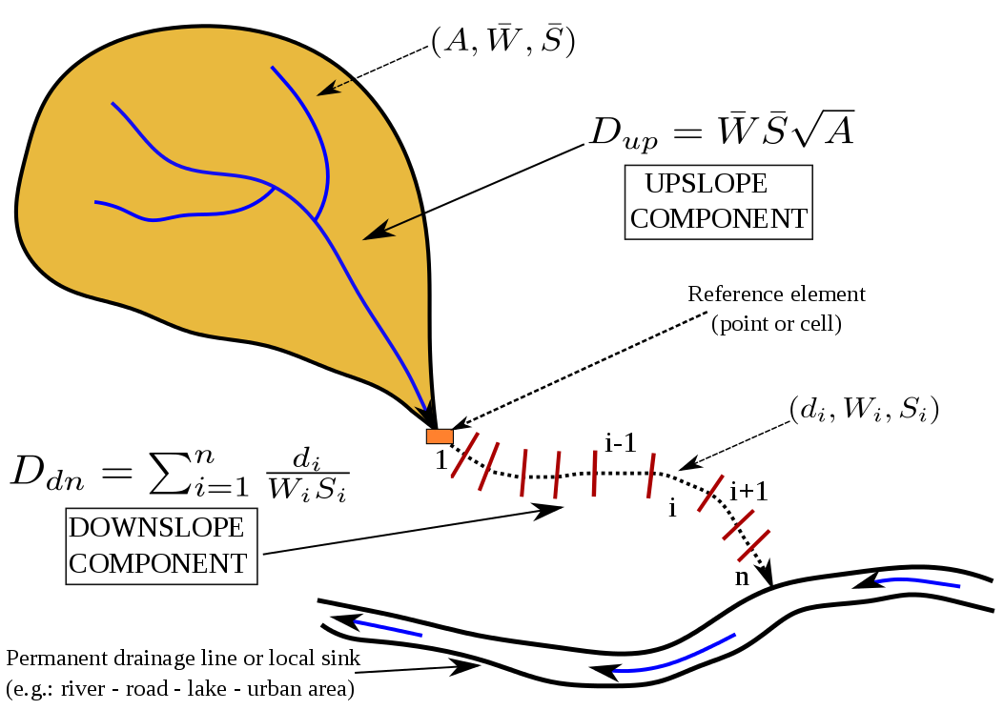

Figure 1. Connectivity index upslope and downslope components (modified after Borselli et al., 2008).

The upslope component *Dup* is the potential for downward routing of the sediment produced upslope and is estimated as follows:

 (2)

where  is the average weighting factor of the upslope contributing area (see later), is the average slope gradient of the upslope contributing area (m/m) and *A* is the upslope contributing area (m2).

The downslope component *Ddn* takes into account the flow path length that a particle has to travel to arrive to the nearest target or sink. Therefore, *Ddn* can be expressed as:

 (3)

where *di* is the length of the flow path along the *i*th cell according to the steepest downslope direction (m), *Wi* and *Si* are the weighting factor and the slope gradient of the *i*th cell, respectively. It is worth noting that *di* can assume two values: cell size (*l*) in the case of cardinal direction and *l√2* in the case of diagonal direction.

## Refinement of the index of sediment connectivity implemented in the tools

The changes made to the original model by Borselli et al. (2008) have been devised to adapt the model to mountain catchments and to its use with High Resolution Digital Terrain Models (HR-DTMs). The changes can be grouped under the following categories: (i) Slope factor computation, (ii) Contributing area calculation, and (iii) Choice of the Weighting factor (W).

### Slope

In the original connectivity model (Borselli et al., 2008), a value of 0.005 m/m was added to the computed value of slope in order to avoid infinites in Eq. 3. In this modified version of the model, we preferred to preserve the slope values calculated directly from the HR-DTM setting a lower limit of 0.005 m/m, for the same reason just explained, and an upper limit of 1 m/m. The upper limit in slope parameter is introduced to limit the bias due to very high values of IC on steep slopes. The setting of a slope upper limit of 1 m/m has also a physical reason: in alpine environment very high slopes are typical of near-vertical rocky cliffs or very steep hillslopes and bedrock channels where sediment storage is difficult. In such a context, processes related to sediment mobilization are mainly represented by rockfalls and not by the processes the proposed sediment connectivity index intends to investigate (i.e. debris flows, bedload transport).

### Contributing area

The tools uses the multiple flow D-infinity approach (Tarboton 1997) to calculate contributing area, instead of the single-flow direction algorithm (O’Callaghan and Mark 1984) applied in the original model.

The advantages of D-infinity over the methods that restrict flow to eight possible directions introducing grid bias (i.e. single-flow direction method) or proportioned flow according to slope introducing unrealistic over-dispersion (i.e. multiple flow direction method) are well known (Tarolli and Dalla Fontana 2009; Hengl and Reuter 2009). In order to correctly model sediment fluxes in mountain catchments, it is fundamental to capture the real flow paths especially on hillslopes where divergent flow predominates. The choice of a reliable algorithm modeling divergent flow is thus reckoned necessary. Another reason that leads to the choice of the D-infinity approach is related to the cell size of HR-DTMs. If the cell size is smaller than the width of the channels in the study area, the use of the single-flow algorithm to derive flow accumulation would limit high-drainage areas (i.e. the channel network) to sequences of single cells, thus underestimating channel widths. In contrast, the D-infinity algorithm better approximates channel width by partitioning flow over the entire cross section. Therefore, the D-infinity algorithm produces a more representative pattern of sediment connectivity through the basins.

### Weighting factor

The weighting factor W, which appears in upslope and downslope components of IC (Eqs. 2 and 3), was introduced by Borselli et al. (2008) to model the impedance to runoff and sediment fluxes due to properties of the local land use and soil surface. Borselli et al. (2008) used the C-factor of USLE-RUSLE models (Wischmeier and Smith 1978; Renard et al. 1997) as weighting factor W. The C-factor, related to vegetation cover and management, attains its maximum value when the soil is more at risk of erosion and approaches zero when the soil is more protected. However, the same authors stressed that W should be derived from the surface characteristics that influence runoff processes and sediment fluxes within a watershed or on a hillslope. Manning’s *n* roughness coefficient meets these requirements; it could be especially suitable, as an alternative to the C-factor, in areas with a great heterogeneity of land use or in the case of a study aiming at evaluating the role of different vegetation covers on sediment dynamic).

LiDAR-derived HR-DTMs permit the computation of geomorphometric indices able to represent fine-scale topographic variability, thus furnishing valuable information on the surface roughness. Accordingly, we decided to propose a local measure of topographic surface roughness, i.e. a roughness index (*RI*), as the weighting factor W. The roughness index is calculated as the standard deviation of the residual topography at a scale of few meters (Cavalli et al. 2008; Cavalli and Marchi 2008). The residual topography is computed as the difference between the original DTM and a smoothed version derived by averaging DTM values on an *nxn* cells moving window. The averaged DTM is necessary to avoid the effect of large scale topography (i.e. slope gradient). Finally, the standard deviations of residual topography values are computed in an *n**n* cells moving window over the residual topography grid. The roughness index is then defined as:

 (4)

where *n2* is the number of the processing cells within the *nxn* cells moving window, *xi* is the value of one specific cell of the residual topography within the moving window, and *xm* is the mean of the *n2* cells values.

The weighting factor is expressed as follow:

 (5)

where *RIMAX* is the maximum value of *RI* in the study area. To avoid infinites or close-to-infinite ratios in Eq. 3, all the values in *W*  that fall in the range 0-0.001 are set to 0.001. This standardization of roughness value, which causes *W* to range from 0.001 to 1, is introduced for three reasons: (i) to have the same range of variation as for S factor in order to weight them equally in the model; (ii) to remove the bias due to high *RI* values, and (iii) to provide comparable values with USLE C-factor and therefore with the original model by Borselli et al. (2008).

The use of a roughness index as weighting factor in the IC has several advantages: i) the weight is estimated objectively; ii) it avoids the use of tabled data such as those used for the C-factor of USLE, which are essentially devised for agricultural environments; iii) it allows the model to be applied straightforwardly, requiring only the DTM as an input. Furthermore, the model by Borselli et al. (2008) focuses on environments that justify the use of the USLE C-factor. Vegetation cover and land use management data used to determine the C-factor are suitable to describe impedance to runoff and sediment fluxes process in agricultural and forest environments. In Alpine catchments, large unvegetated areas are present with different surface roughness depending on the characteristics of outcropping rock and debris cover. In these bare areas, the C-factor would not provide differences in the impedance to sediment transport, which can be better represented by a proxy based on topographic roughness. Moreover, a roughness-based index is more suited for modeling sediment transfer by debris flows, which have a major role in sediment-related processes in Alpine basins. In such a context, we argue that the characterization of surface roughness represents a better proxy for sediment transport impedance compared to the C-factor.

It is important to emphasize that the choice of the weighting factor W related to the impedance to sediment fluxes is free. This means that, according to the objective of the study, the user can use different parameters expressing the impedance to sediment fluxes (e.g., C-factor of the USLE as in the Borselli et al., 2008, Manning’s n, or topographic roughness computed on a high-resolution DTM). A basic requirement to be met is that the weighting factor varies on the range >0 to 1.

# Stand-alone application

## Requirements

The stand-alone application requires TauDEM tools (http://hydrology.usu.edu/taudem/taudem5/index.html) installation since several hydrological functions are computed exploiting this suite. For TauDEM tools installation refer to the following steps:

* Recommendation: turn UAC (User Account Control) to the lowest value to prevent Windows from blocking MPI activity. To do this type “*uac”* in the start dialogue, turn the level low and confirm.

 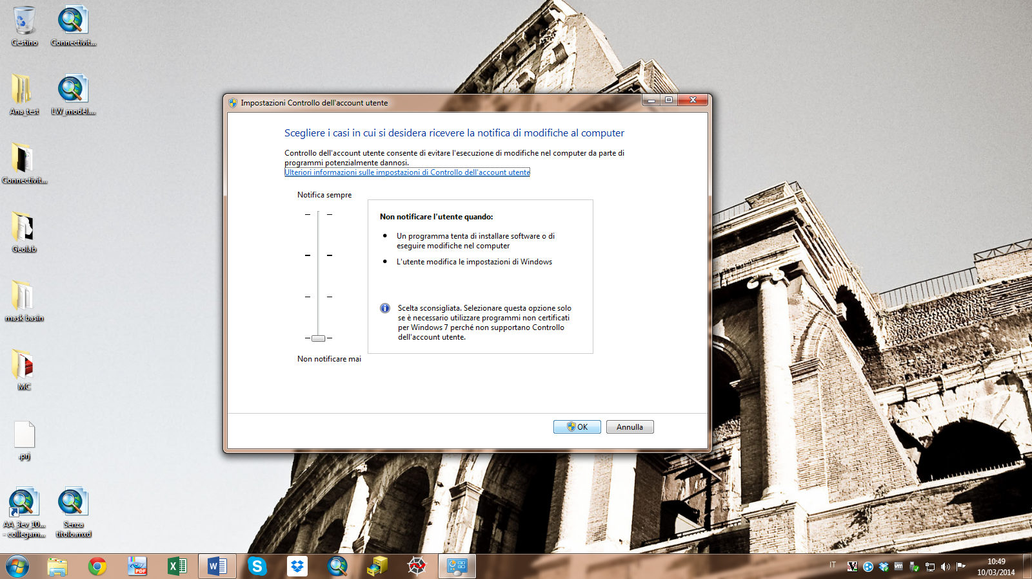

* Download and install TauDEM 5.1.1 (tested version) from:

<http://hydrology.usu.edu/taudem/taudem5/taudem511exe.html>

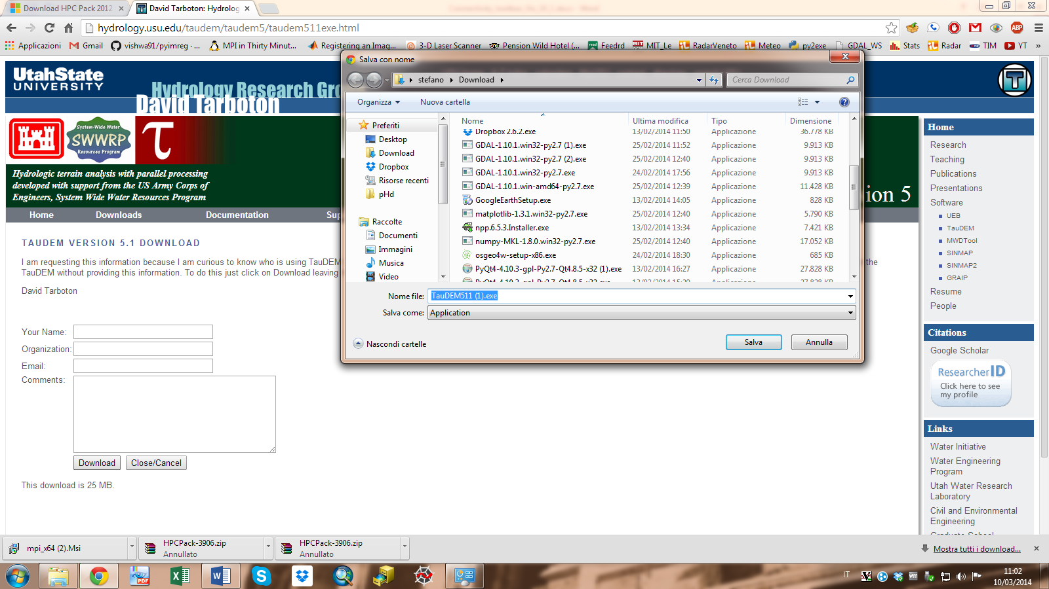

* It is recommended to install TauDEM with administrative privileges. To do this right-click on the downloaded file and select ***Run as administrator***.

TauDEM installation requires [HPC Pack 2012](http://www.microsoft.com/en-us/download/confirmation.aspx?id=36045) and [Microsoft visual C++ 2010](http://www.microsoft.com/it-it/download/details.aspx?id=5555) runtime libraries. During the installation, their presence in the system will be automatically checked. In the negative case, you will have to install the proposed dependencies following the installer suggestions.



* If at any time during the installations (HPC, Visual C++ or TauDEM) you receive a firewall message like the following:



click *Cancel* and continue because the utility does not need to communicate with external resources.

## Application features

The development of the stand-alone application **(SedInConnect 2.0)** started as a bottom-up approach. We verified the need of such an application while interacting and exchanging feedbacks with researchers and management authorities interested in the connectivity assessment.

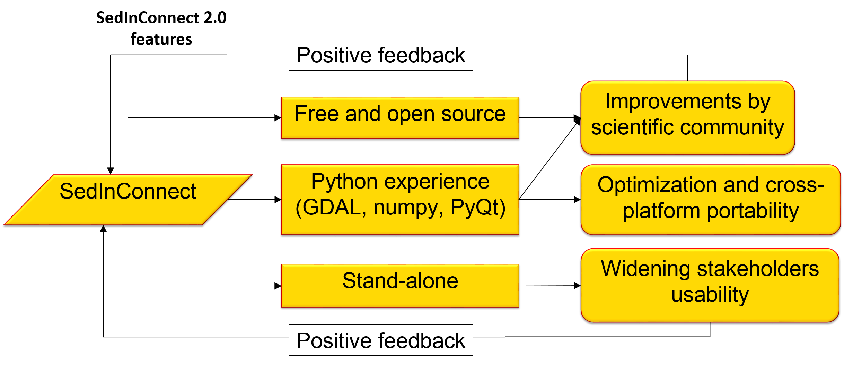

Figure 4. Main features and expected feedbacks of SedInConnect 2.0 application.

The main features (Fig. 4), characterizing the application development are:

* Free application and open source code 🡪 thus encouraging its usage and receiving improvements from the scientific community.
* Development based on the Python Experience 🡪 exploiting already available libraries for the efficient analysis of geographic dataset, for the creation of Graphical User Interfaces and guaranteeing a cross platform portability (Windows/Linux/MacOS) thus enhancing the potential users’ community.
* Stand-alone application 🡪 in order to be independent from any GIS software knowledge to be more usable also by management authorities less involved in research issues but very close to management issues and priorities.

### Workflow

The workflow of the stand-alone application is herein reported (Fig. 5). It introduces a couple of novel features compared to the ArcGIS toolbox.

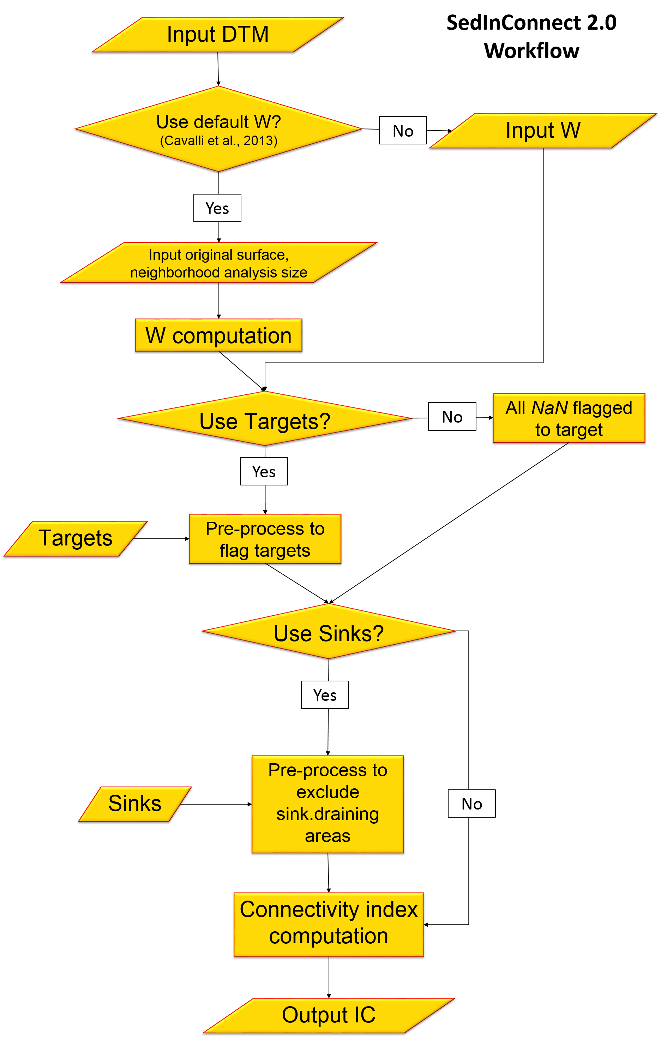

Figure 5. SedInConnect 2.0 workflow.

In this implementation, as it is for the ArcGis toolbox, the user can optionally choose to run the computation with the proposed weighting factor, derived from the Roughness Index as in Cavalli et al. (2013), or feel free to choose any other weighting factor. If the option goes for the surface roughness-derived weighting factor, the normalization procedure (Eq. 5) is automatically carried out inside the application and the process becomes easier and straightforward for the user. Another novel improvement consists in the introduction of **sink features**: these features can optionally be introduced to decouple all the sink-draining areas from the connectivity assessment. Sink features should have an active role in the trapping of sediment. To give an example a check dam with an upstream retention basin can be considered a sink feature for sediment (at least until the storage capacity of the basin is filled) and can be introduced in the analysis, thus decoupling all the upcoming sediment and not considering this upstream area in the connectivity evaluation downstream.

### Implementation and usage

The stand-alone SedInConnect 2.0 application is provided as a single executable Windows file (for 64-bit Operative Systems) along with its *Python* source code and license (GPL v.2).

At present the application is working with some features in beta version; future releases and ameliorations will focus primarily on the stand-alone application due to the greater flexibility in the data management and processing with respect to the ArcGis toolbox.

The application has been tested with file size < 4GB, more generally, the user should consider the total amount of available RAM on the PC and use input files whose size is less than half the total RAM size. Doing this way, the PC memory will be enough to load the input raster and to do processing operations on it.

The whole code for the tool’s implementation is provided within the [SedAlp](http://www.sedalp.eu/) website under the tools session. The code and the application are provided under the GNU General Public License version 2 in accordance with the TauDEM Tools license. After downloading the tool from the following address <http://www.sedalp.eu/download/tools.shtml>, uncompress the archive and launch the executable.

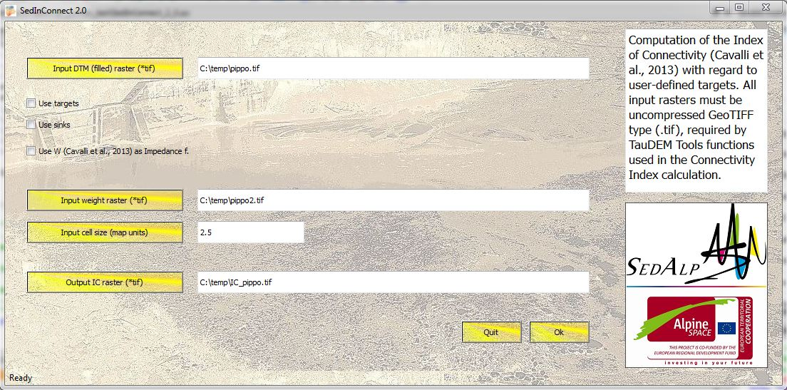

2

1

4

3

Once the tool is open, the user can decide to run the application with minimum input/output requirements (as shown in the above screenshot):

1. Input DTM file: here the input DTM must be set.

The input DTM is usually hydrologically correct (with pits removed) to obtain a catchment-scale connectivity, but it is not compulsory. In case you want to keep the local depressions, each depression will act as a “sink” for upstream sediment in the final map. In this case, the connectivity will be computed with respect to the catchment outlet but all the areas draining to local depressions will report connectivity values with respect to these depressions. Downstream the local depression, the computation restarts until the next depression or the outlet. Running the tool using a DTM without removing local depressions could lead to interesting analyses considering automatically detected sediment sinks. **Nevertheless, it is important to point out that local depressions in a DTM are not always real sinks (e.g. dolines) but are generally artifacts of the DEM creation process that interfere with the flow routing and thus need to be removed.** For consistency with the algorithms used in the connectivity model, we suggest to use the Pit Remove algorithm of TauDEM that identifies all pits in the DEM and raises their elevation to the level of the lowest pour point around their edge.

Regarding the extent of the analysis, all the procedure should be carried out over a buffer of the selected catchment. This buffer is necessary to avoid errors or approximations related to border effects. We suggest a buffer of few pixels greater than the basin. At the end of the connectivity assessment, the output connectivity map must be clipped over the catchment mask in order to carry out any analysis on the catchment values distribution.

Since the Connectivity Index is numerically computed with respect to all the *NoData* values, it is a good practice to keep the buffer very close to the outlet (a couple of pixel is enough) while it can be wider in the rest of the study area. This last caution is important to be sure that IC is computed in relation to the desired outlet.

1. Weighting factor raster: here the weighting factor raster must be set.

In case the user wants to adopt surface roughness as a proxy to impedance to the sediment fluxes. As already mentioned in the background theory section, **according to the required analysis and to the characteristics of the study area, the user can choose the most suitable weighting factor**.

1. Cell size: here the input cell size in map units must be indicated. This value will be used to process drainage data to obtain unit values.
2. Output Connectivity Index map: here path and name of the output IC map are set.

The map needs to be clipped with a mask of the catchment in order to exclude all the values in the buffer area not included in the analysis.

**All input raster files have to be in GeoTIFF format** since TauDEM works only with this format and **must have** **the same extent, origin, number of rows and columns**.

The operation on temporary files are carried out on the folder that contains the DTM input file. Thus, it is recommended to clean that folder from any temporary present file related to previous runs of the model.

As shown in next screenshot, the user can decide to integrate the analysis with the introduction of target features (2) and sink features (3). The user can also decide to use the weighting factor proposed in Cavalli et al. (2013) and let the tool compute and use it, in this case the user is asked (4) to introduce the original DTM (without pit removal) in order to correctly compute the surface roughness to derive the flow impedance factor. Surface roughness (5) and the weight raster (7) are saved to a GeoTIFF file so as they can be analyzed or used in other analyses (or following runs of the model, without requiring the weight computation again).

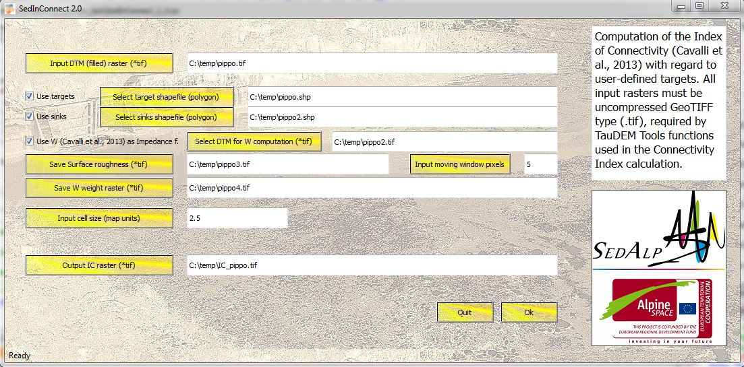

4

2

1

9

8

7

5

6

3

In order to calculate the surface roughness as proposed by Cavalli et al. (2008), the user is asked (6) to introduce the number of pixel that define the size of the moving window to consider while smoothing the original DTM and for the computation of the standard deviation of residual topography.

The sink features must be polygon shapefiles; the most computational efficient way of introducing sink features is using a buffer (2 pixels side by side) of the sink area perimeter, but a complete polygon will work anyway, maybe increasing remarkably the computational time. In order to run the model correctly, the sink shapefile needs to have an attribute field called exactly “*sink\_id*” populated with values strictly **>0**.

Apart from the main ouputs (IC, surface roughness and weighting factor rasters), SeInConnect 2.0 gives a first overview of IC map printing an image to screen (Fig. 6a). In the case the target option is chosen, (the only option where there is no portion potentially outside the catchment considered) IC distribution is also printed to screen along with the main related statistics (Fig. 6b). The user can browse, zoom and/or save the images (IC, and statistics) to have a first assessment of the IC distribution.

b

a

|  |  |
| --- | --- |
| C:\Users\stefano\Dropbox\qt_python_test\ic_tg.png | C:\Users\stefano\Dropbox\qt_python_test\ic_tg_stat.png |

Figure 6. IC output map (a) and distribution with descriptive statistics (b) in the case the target option is selected.

* For **more information** on TauDEM installation, see also the following:

<http://hydrology.usu.edu/taudem/taudem5/TauDEM51GettingStartedGuide.pdf>

and/or:

<http://hydrology.usu.edu/taudem/taudem5/TauDEM51CommandLineGuide.pdf>

* For **troubleshooting on TauDEM** installation/working check also:

<http://hydrology.usu.edu/taudem/taudem5/support.html>

and:

<http://hydrology.usu.edu/taudem/taudem5/troubleshooting.html>

* For **troubleshooting on the Connectivity ToolBox or stand-alone application** usage write to:

[stefano.crema@irpi.cnr.it](mailto:stefano.crema@irpi.cnr.it)

or:

[marco.cavalli@irpi.cnr.it](mailto:marco.cavalli@irpi.cnr.it)

# References

Baartman JEM, Masselink R, Keesstra SD, Temme AJAM. 2013. Linking landscape morphological complexity and sediment connectivity. Earth Surface Processes and Landforms 38: 1457–1471. DOI: 10.1002/esp.3434

Borselli L, Cassi P, Torri D. 2008. Prolegomena to sediment and flow connectivity in the landscape: A GIS and field numerical assessment. CATENA 75: 268–277. DOI: 10.1016/j.catena.2008.07.006

Cavalli M, Marchi L. 2008. Characterisation of the surface morphology of an alpine alluvial fan using airborne LiDAR. Nat. Hazards Earth Syst. Sci. 8: 323–333. DOI: 10.5194/nhess-8-323-2008

Cavalli M, Tarolli P, Marchi L, Dalla Fontana G. 2008. The effectiveness of airborne LiDAR data in the recognition of channel-bed morphology. CATENA 73: 249–260. DOI: 10.1016/j.catena.2007.11.001

Cavalli M, Trevisani S, Comiti F, Marchi L. 2013. Geomorphometric assessment of spatial sediment connectivity in small Alpine catchments. Geomorphology 188: 31–41. DOI: 10.1016/j.geomorph.2012.05.007

ESRI. 2012. ArcGis 10.1. Environmental System Research Institute, Inc, Redlands, CA

Fryirs K. 2013. (Dis)Connectivity in catchment sediment cascades: a fresh look at the sediment delivery problem. Earth Surface Processes and Landforms 38: 30–46. DOI: 10.1002/esp.3242

Heckmann T, Schwanghart W. 2013. Geomorphic coupling and sediment connectivity in an alpine catchment — Exploring sediment cascades using graph theory. Geomorphology 182: 89–103. DOI: 10.1016/j.geomorph.2012.10.033

Hengl T, Reuter HI. 2009. Geomorphometry: Concepts, Software, Applications. 1 edition. Elsevier Science: Amsterdam, Netherlands ; Oxford, UK ; Boston Mass.

Meßenzehl K, Hoffmann T, Dikau R. 2014. Sediment connectivity in the high-alpine valley of Val Müschauns, Swiss National Park – linking geomorphic field mapping with geomorphometric modelling. Geomorphology DOI: 10.1016/j.geomorph.2014.05.033

O’Callaghan JF, Mark DM. 1984. The extraction of drainage networks from digital elevation data. Computer vision, graphics, and image processing 28: 323–344.

Renard KG, Foster GR, Weesies GA, McCool DK, Yoder DC. 1997. Predicting soil erosion by water: a guide to conservation planning with the Revised Universal Soil Loss Equation (RUSLE). No 703: xix + 384 pp.

Tarboton DG. 1997. A new method for the determination of flow directions and upslope areas in grid digital elevation models. Water Resources Research 33 : 309–319. DOI: 10.1029/96WR03137

Tarboton DG. 2013. Taudem 5.1, Terrain Analysis Using Digital Elevation Models [online] Available from: http://hydrology.usu.edu/taudem/taudem5/

Wischmeier WH, Smith DD. 1978. Predicting rainfall erosion losses - a guide to conservation planning. U.S. Department of Agriculture